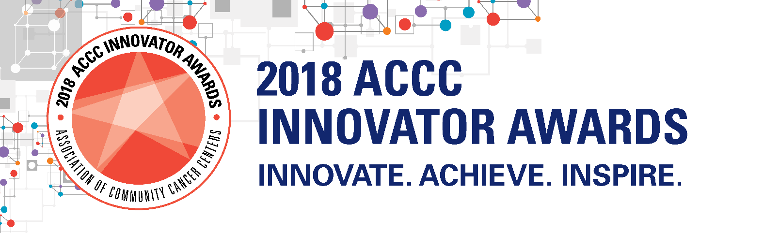

**Application Deadline:** March 9, 2018

|  |
| --- |
| **All applicants must be affiliated with ACCC as a Cancer Program Member!**  To confirm membership, please contact Arnold Sripinyo, Assistant Manager of Membership by emailing [asripinyo@accc-cancer.org](mailto:asripinyo@accc-cancer.org) or dialing 301.984.9496, ext. 267. |

**Primary Contact for Entry**

Prefix ___ First Name _______________ Last Name _____________________ Suffix ___ Designation ____

Title/Position __________________________________________________________________

Email Address _________________________________________________________________

Telephone ________________________________

**Cancer Program Information**

Hospital/System/Practice Name ____________________________________________________

Cancer Program Name ___________________________________________________________

Address _______________________________________________________________________

City, State, Zip __________________________________________________________________

**Innovator Award Entry Title** ________________________________________________________

**Summary of your innovation, and its impact on your cancer program and your patients**

(750 words or less).

**Which category best fits your innovation?**

* New Models in Care Coordination
* At-Risk and Underserved Populations
* Process Improvement Strategies
* Supportive Care Services
* Quality Improvement Initiatives
* Immuno-Oncology Implementation
* Community Outreach, Prevention & Screenings
* Other _________________________________________

**Describe how you would present your innovation at the ACCC 35th National Oncology Conference, including your top three takeaways.**

**Please provide the name, credentials, and a 50-word biography for the individual who would present your innovative program.**

**Terms of Agreement:**

By submitting this form, you agree to meet all posted dates and deadlines.

**Completed entry forms may be submitted in any of the following ways:**

1. Mail your application to the Association of Community Cancer Centers (ACCC) at the following address:

**Attn: ACCC Innovator Award**

**Association of Community Cancer Centers**

**1801 Research Bvld. Suite. 400**

**Rockville, MD 20850**

1. Faxed your application to 301.770.1949, Attn: ACCC Innovator Award
2. Email your application to [innovatorawards@accc-cancer.org](mailto:innovatorawards@accc-cancer.org)

Thank you for your ACCC Innovator Award entry. **You will be notified by May 4, 2018**, on the status of your submission. If you have any questions, please email [innovatorawards@accc-cancer.org](mailto:innovatorawards@accc-cancer.org), or call 301.984.9496 ext.227.