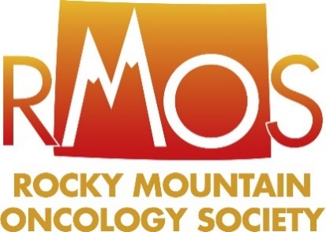

**Educational Award for Allied Health Professionals**

***Submission Deadline:***

***Friday, September 29, 2023***

**OVERVIEW**

The Rocky Mountain Oncology Society (RMOS) is committed to focusing on the future of cancer care in Colorado by supporting the professional development by supporting the professional development of **Advanced Practice Providers, Pharmacists and Registered Nurses** in the state. The leadership of RMOS believes that supporting the educational goals of allied healthcare professionals is vital to the future of cancer care delivery in Colorado and to the mission of the Society.

As such, a subcommittee of members on the RMOS Board of Directors will review the applications and select up to ten (10) participants to receive a $2,000 stipend to attend Best of ASCO conference or other applicable **live or virtual** meeting—including but not limited to—the American Society of Hematology (ASH), Oncology Nursing Society (ONS), or the Association of Community Cancer Centers (ACCC). Participants may also use the award to enrich their professional development and apply it to coursework that is not reimbursable.

RMOS reserves the right to accept and review applications. This competition limits winners to apply once every two years.

**Directions**

Applicant must:

* Complete the application and submission electronically through the RMOS website, via email to **aimpellizzeri@accc-cancer.org** with the attached form.
* Ensure the application arrives no later than **Friday, September 29, 2023.**
* Clearly print your name, designation/ title, institution (affiliation), address, telephone number and email address.
* Be a current member of RMOS.

**Questions?**

E-mail **Amanda Impellizzeri, Leadership Relations Manager at** [aimpellizzeri@accc-cancer.org](mailto:aimpellizzeri@accc-cancer.org)

# S:\CMI CLIENTS\OSSN\Colorado-Rocky Mountain Oncology Society (RMOS)\Forms\Logo-Art\Colorado LOGO C.jpg

## Educational Award Application

|  |  |  |  |  |
| --- | --- | --- | --- | --- |
| Contact Information | | | | |
| Name/Designation: | |  | Date: |  | | |
| Institution/Practice: | |  | Email: |  | | |
| Mailing Address: | |  | | | | |
| Telephone: | |  | | | |
| Title: |  | | | | | |
|  | | | | |
| Statement Summary & Qualifications | | | | |

Why are you applying for this award?

Should your application be selected, what meeting(s)/coursework would you use the award toward and why?

How would this award help you to advance in your career? Please explain your professional objectives and/or goals:

Are you a current member of RMOS?

Any additional information you’d like us to know?

*For your application to be considered, all applicants must be current members of RMOS.

If you would like to submit an application and you are not a member or you do not know your membership status, please contact Hayeon Cho, Membership Associate (hcho@accc-cancer.org) or call 301.984.9496 ext. 230.

You can join the society through the RMOS website at [www.rmos-colorado.com](http://www.rmos-colorado.com)