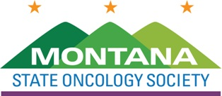

Click to enter a date

Choose an item Enter First & Last Name
Title
Select company name

Dear Choose an item Last Name,

The Montana State Oncology Society (MSOS) Board of Directors invites your company to attend and display at the MSOS 2021 Fall Conference, November 2, 2021, at the DoubleTree by Hilton Hotel Billings in Billings, Montana.

The $2,500 Exhibitor fee includes:
- Draped, display table, no electricity
- Up to two (2) registrants, who may attend all open programming
- Company recognized in the conference program
- Networking opportunities with the organization’s leadership and membership

We anticipate 50-100 attendees to include physicians, physician assistants, nurse practitioners, pharmacists, and registered nurses.

If you have any questions, please contact April M. Gascón, agascon@accc-cancer.org (301-984-9496 ext. 225).

We appreciate your support and thank you in advance for your participation.

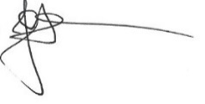
Best Regards,

Jack Hensold, MD
Board President

CONFERENCE EXHIBITOR PAYMENT INFORMATION:
Montana State Oncology Society (Tax ID # 32-0454325)

Exhibitor Fee $2,500
Return with Check Payable to: Montana State Oncology Society
1801 Research Boulevard, Suite 400
Rockville, MD 20850
Contact our Accounting Assistant at 301.984.5067 to inquire about making payment by ACH

