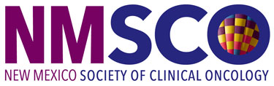

Click to enter a date

Choose an item Enter First & Last Name
[INSERT YOUR COMPANY’S NAME HERE]

Dear Choose an item Enter your last name

The New Mexico Society of Clinical Oncology (NMSCO) Board of Directors invites [INSERT YOUR COMPANY’S NAME HERE] to attend and display at our NMSCO 2022 Inaugural Oncology Conference on October 8, 2022 at the Sandia Resort & Casino in New Mexico.

The $3,000 registration fee includes:
⊳ draped display table, no electricity
⊳ up to two (2) registrants, who may attend all open programming
⊳ exhibiting company recognized in the conference program
⊳ select your table from unassigned display tables

We anticipate 100 attendees to include physicians, physician assistants, nurse practitioners, pharmacists, and registered nurses.

NMSCO is a 501(c)6, not for profit. The society’s tax identification number is 85-0392445. Please make your check payable to:

New Mexico Society of Clinical Oncology
1801 Research Boulevard, Suite 400
Rockville, MD 20850

We ask that you direct questions to Lea Njosa at CorporateRelations@accc-cancer.org or by phone at 301.984.9496, ext. 225.
We appreciate your support and thank you in advance for your participation.

Best regards,
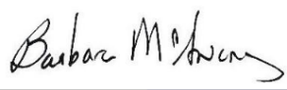
Barbara L. McAneny, MD
President
New Mexico

