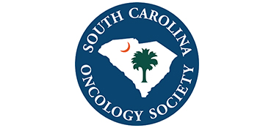

Click to enter a date

Choose an item Enter First & Last Name
[INSERT YOUR COMPANY’S NAME HERE]

Dear Choose an item Enter your last name

The South Carolina Oncology Society (SCOS) Board of Directors invites [INSERT YOUR COMPANY’S NAME HERE] to attend and display at our SCOS 2022 Annual Conference on August 5 to August 6, 2022, at the Wild Dunes Resort in Isle of Palms, South Carolina.

The $2,500 registration fee includes:
⊳ draped display table, no electricity
⊳ up to two (2) registrants, who may attend all open programming
⊳ exhibiting company recognized in the conference program
⊳ select your table from unassigned display tables

We anticipate 100 attendees to include physicians, physician assistants, nurse practitioners, pharmacists, and registered nurses.

SCOS is a 501(c)6, not for profit. The society’s tax identification number is 57-0732587. Please make your check payable to:

South Carolina Oncology Society
1801 Research Blvd, Suite 400
Rockville, MD 20850

We ask that you direct questions to Lea Njosa at CorporateRelations@accc-cancer.org or by phone at 301.984.9496, ext. 225.

We appreciate your support and thank you in advance for your participation.

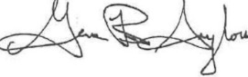
Best Regards,

Gene B. Saylors, MD
President
South Carolina Oncology Society

