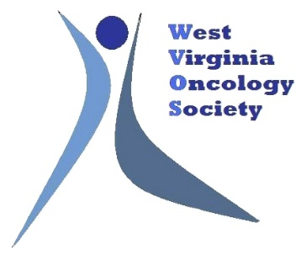

Click to enter a date

Choose an item Enter First & Last Name
[INSERT YOUR COMPANY’S NAME HERE]

Dear Choose an item Enter your last name

The West Virginia Oncology Society (WVOS) Board of Directors invites [INSERT YOUR COMPANY’S NAME HERE] to attend and display at our WVOS 2022 Spring Conference on April 1, 2022 at The Stonewall Resort in Roanoke, WV.

The $2,500 registration fee includes:
⊳ draped, display table, no electricity
⊳ up to two (2) registrants, who may attend all open programming
⊳ your company recognized in the conference program

We anticipate 100 attendees to include physicians, physician assistants, nurse practitioners, pharmacists, and registered nurses.

WVOS is a 501(c)6, not for profit. The society’s tax identification number is 26-2558397. Please make your check payable to:
West Virginia Oncology Society
1801 Research Blvd, Suite 400
Rockville, MD 20850
Please direct questions to Lea Njosa at CorporateRelations@accc-cancer.org or by phone at 301.984.9496, ext. 225.
We appreciate your support and thank you in advance for your participation.

Best Regards,
Ghulam Abbas, MD, MHCM, FACS
President
West Virginia Oncology Society

